Assessment Round 1

1 While activating account Without Fill the Account Activation Summary Field—>

For this case I create a validation rules –>

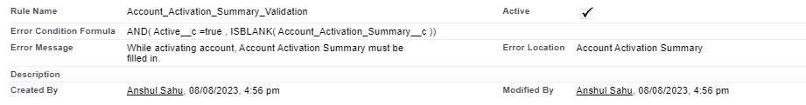

Below is screenshot with error Message

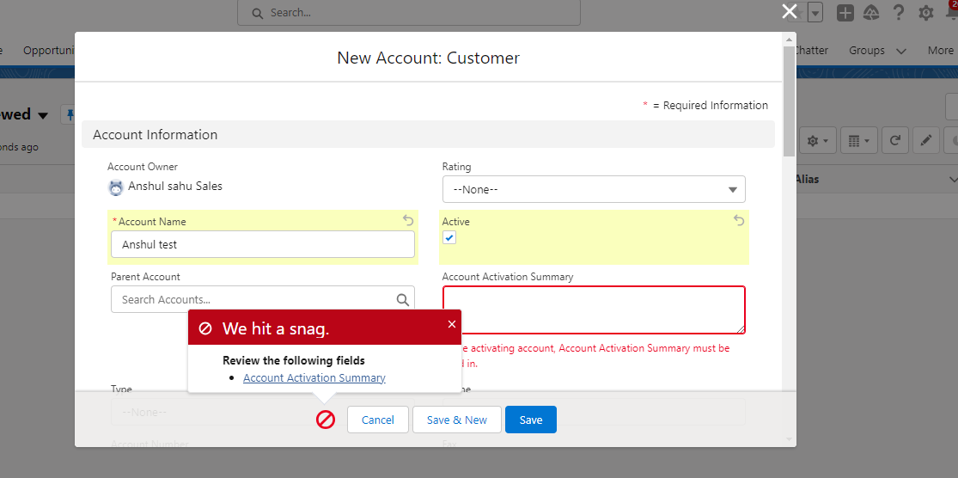

2. When an active account record is created, or an account is activated, and there is no child contact record in Account, Create the contact With account’s Value->

For this case I create a trigger on account-

Below screenshot with tested record-

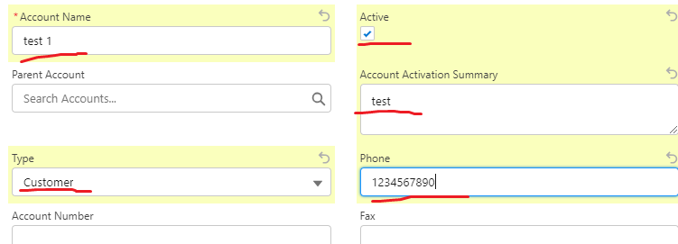

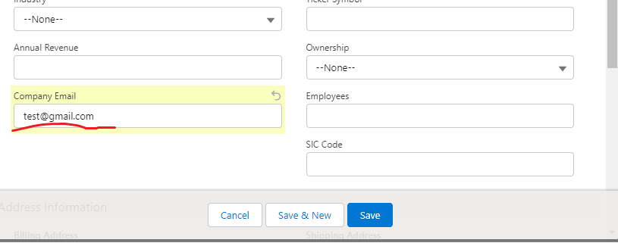

Conatct insert 🡪

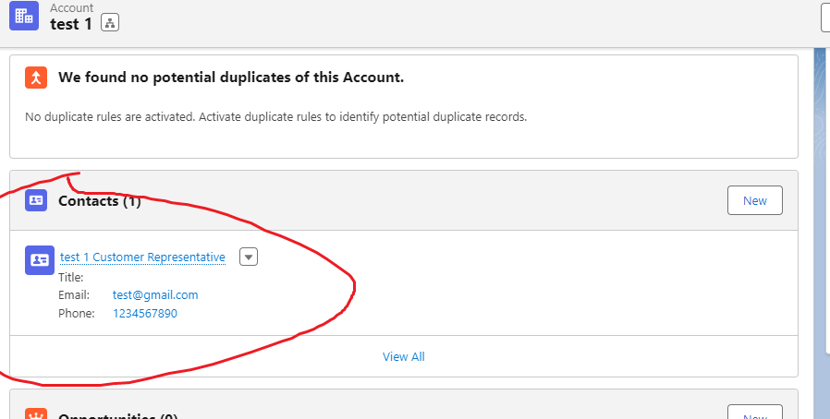

3 based on third requirement I create Action Button ->

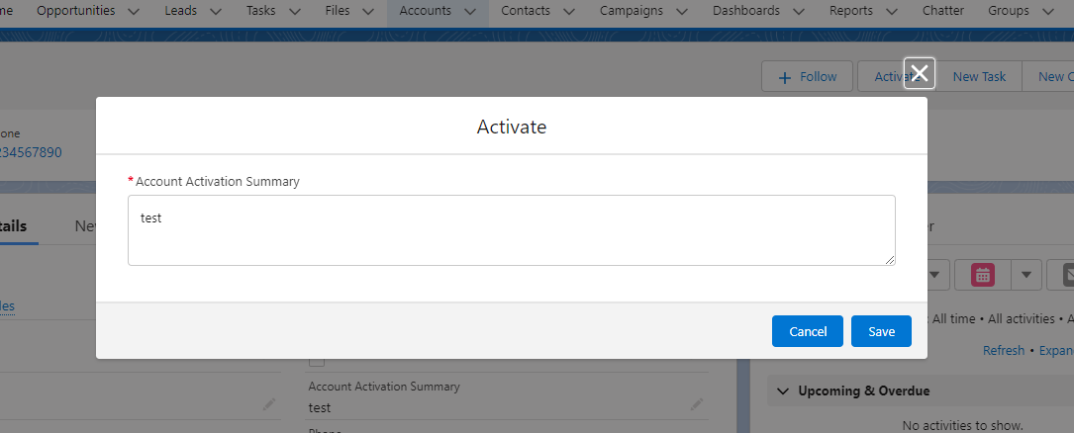

I put Predefined field value--> active=true and account activation summary field is required Also action button only visible when the active =false

**Apex backend components:**

1. AccountTrigger

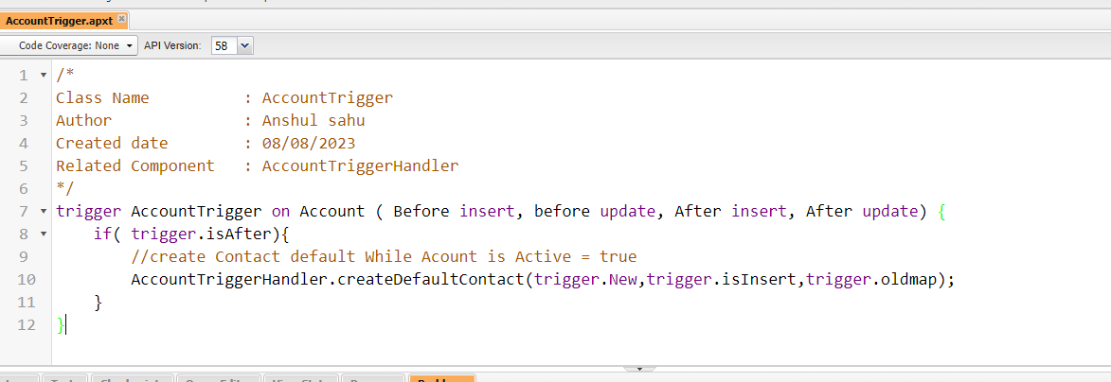

2) AccountTriggerHandler

/*

Class Name : AccountTriggerHandler

Author : Anshul sahu

Created date : 08/08/2023

Description : This helper class used in AccountTrigger

*/

public class AccountTriggerHandler {

//create Contact default While Acount is Active = true and customer type = Customer if a default contact does not exist.

public static void createDefaultContact(List<Account> newList, Boolean isInsert, Map<Id,Account> oldMap){

Set<Id> accIds = new Set<Id> (); //for Store the Account ids

List<Contact> conList = new List<Contact>(); //for Store the contacts

for(Account acc:newList){

if((isInsert || acc.Active__c !=oldMap.get(acc.Id).Active__c) && acc.Active__c == true && acc.Type == System.label.Customer ){

accIds.add(acc.Id);

}

}

if(accIds.size()>0){

List<account> accList = [SELECT Id, Name, Phone, Company_Email__c, (SELECT Id FROM Contacts LIMIT 1) FROM Account WHERE Id IN:accIds];

for(Account ac:accList){

if(ac.contacts.size()==0){

Contact con = CreateContact(ac);

conList.add(con);

}

}

if(conList.size()>0)

Database.insert(conList) ; // insert the contact

}

}

/*****************************************************

* Method Name : createContact

* Author : Anshul sahu

* Description : This method is used to create and return the contact

* Created Date : 08/08/2023

* Related Component : createDefaultContact

*****************************************************/

public static Contact createContact(Account acc){

Contact con = new Contact();

con.firstName = acc.Name;

con.lastName = System.label.Customer_Repre;

con.Phone = acc.Phone;

con.Email = acc.Company_Email__c;

con.AccountId = acc.id;

return con;

}

}